|  |  |  |
| --- | --- | --- |
|  | **INSTITUCIÓN *EDUCATIVA HORACIO MUÑOZ SUESCUN***  ***TÉCNICO COMERCIAL***  **Resolución de Aprobación 16314 del 27 de Noviembre de 2002**  **DANE: 105001011606 NIT: 811.019.157-3**  **“Educamos comercialmente para servir”** | **GDA: 08**  **V: 01**  **9/05/2013** |
| **GUIA DE APRENDIZAJE PERIODO I II III IV V** |

|  |
| --- |
| **Espacio para llenar por el estudiante.** |
| NOMBRES Y APELLIDOS DEL ESTUDIANTE |
| GRADO: GRUPO: |
| NOMBRES Y APELLIDOS DEL DOCENTE: SUSANA RIVERO SILVA susanarivero@iehoracio.edu.co |
| ÁREA Y/O ASIGNATURA: INGLES |

**Vea los siguients videos:**

[**https://www.youtube.com/watch?v=wLuNOWXw96c**](https://www.youtube.com/watch?v=wLuNOWXw96c)

[**https://www.youtube.com/watch?v=-PjxWSLGXo8**](https://www.youtube.com/watch?v=-PjxWSLGXo8)

[**https://www.youtube.com/watch?v=6ATj9Do_RL8**](https://www.youtube.com/watch?v=6ATj9Do_RL8)

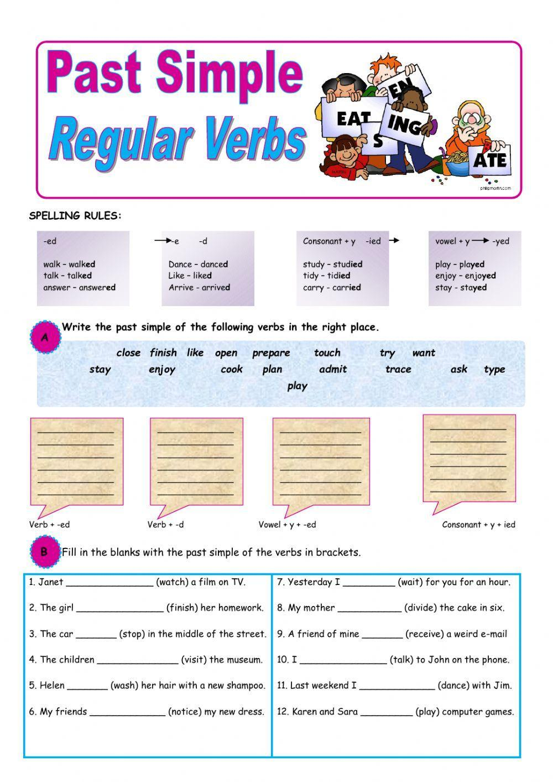**PAST SIMPLE**

|  |  |  |
| --- | --- | --- |
|  | **INSTITUCIÓN *EDUCATIVA HORACIO MUÑOZ SUESCUN***  ***TÉCNICO COMERCIAL***  **Resolución de Aprobación 16314 del 27 de Noviembre de 2002**  **DANE: 105001011606 NIT: 811.019.157-3**  **“Educamos comercialmente para servir”** | **GDA: 08**  **V: 01**  **9/05/2013** |
| **GUIA DE APRENDIZAJE II PERIODO** |



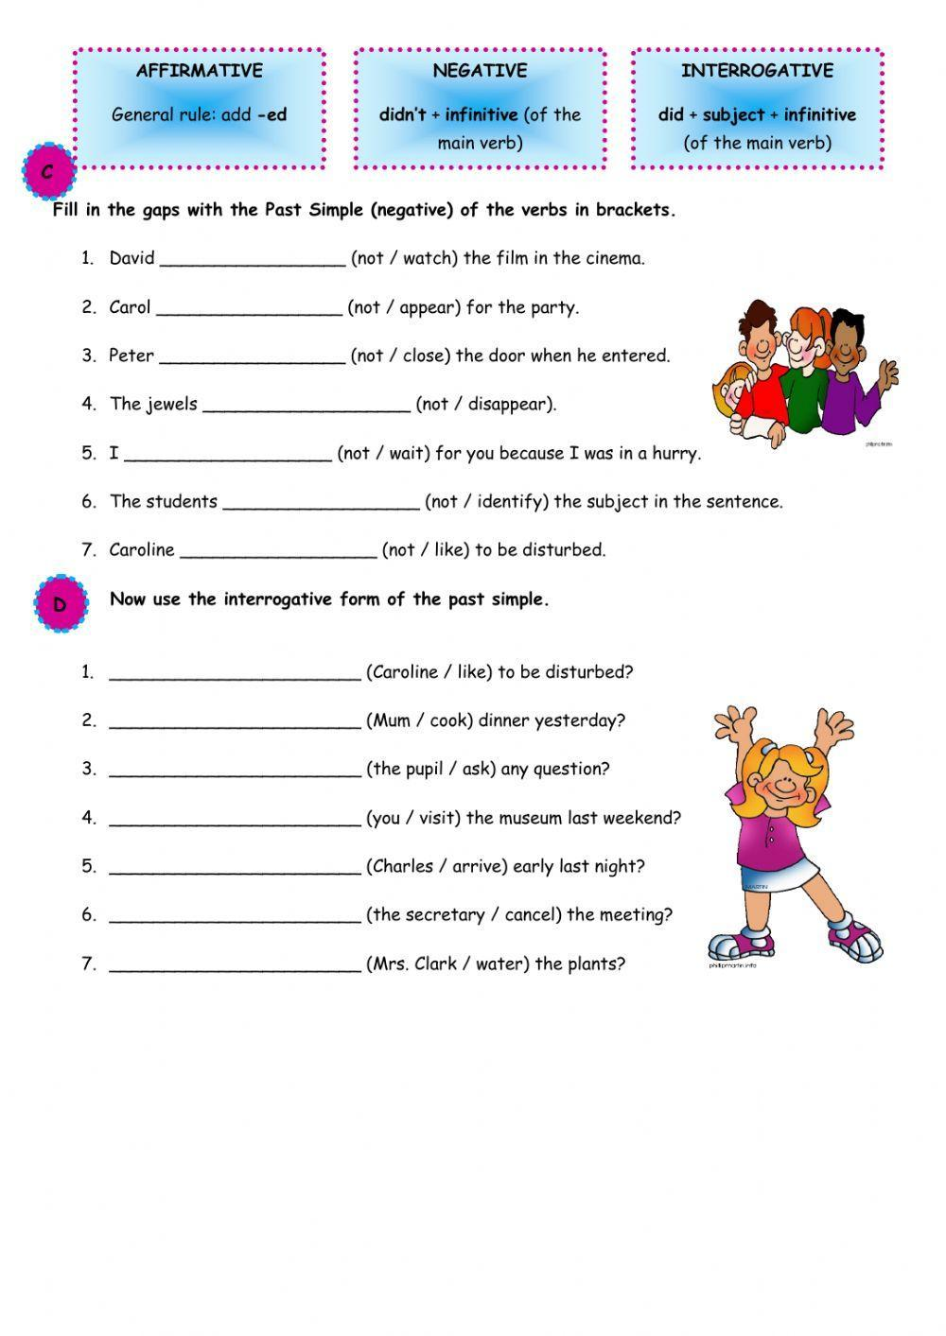



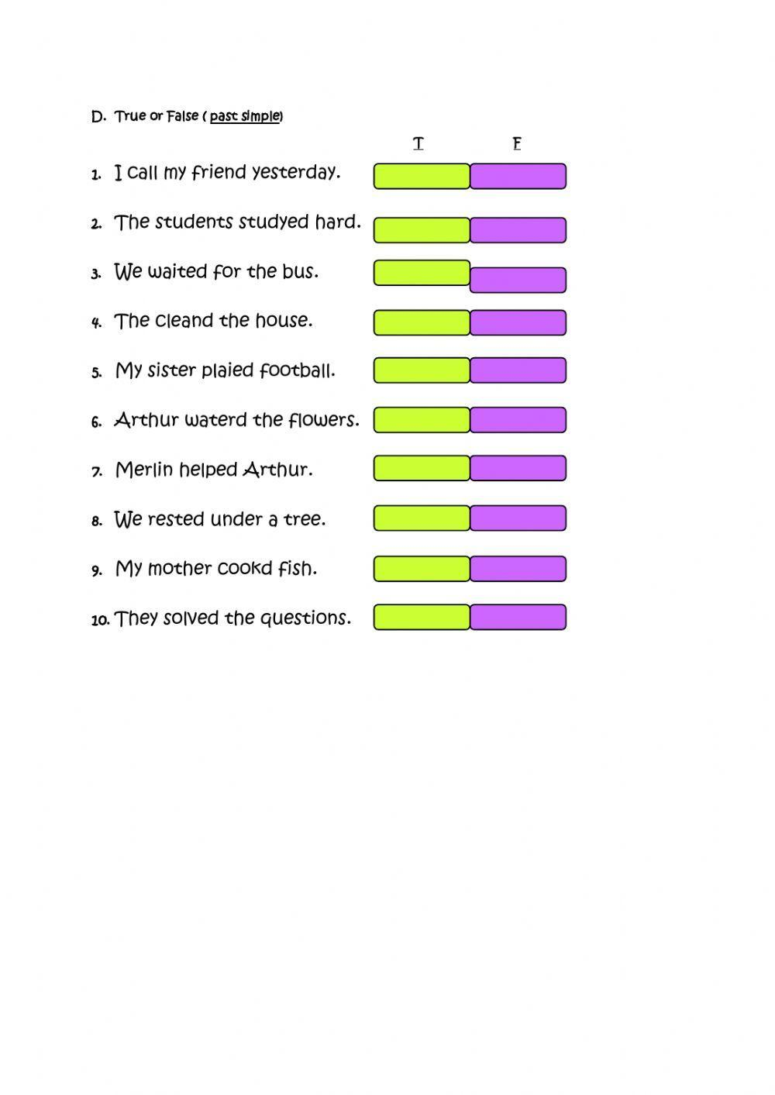

**IRREGULAR VERB**

**E. PUT THE VERBS IN THE PAST SIMPLE**

1. Be----------- ----------

2. Buy----------------------

3. Catch-----------------------

4. Choose----------------------

5. Do---------------------------

6. Drink-------------------------

7. Drive--------------------------

8. Eat--------------------------

9. Find--------------------------

10. Forget------------------------

11. Get--------------------------

12. Give--------------------------

13. Go----------------------------

14. Hear--------------------------

15. Know-------------------------

16. Make-----------------------

17. Meet-------------------------

18. Put--------------------------

19. Read-----------------------

20. Ride------------------------

21. Run--------------------------

22. Say-----------------------

23. See--------------------------

24. Sleep--------------------------

25. Speak-------------------------

26. Take ------------------------

27. Think ------------------------

28. Write-------------------------

**F.IN THE LIST OF IRREGULAR VERBS 4BE” IS A LITTLE SPECIAL BECAUSE IT DOESN’T NEED 4DID” TO MAKE QUESTIONS OR NEGATIVE SENTENCES.**

Put “Be” in the correct form of the past in the following sentences.

* + 1. I very tired yesterday night.
    2. They at the cinema.
    3. She angry with her pupils.
    4. My mum at hospital last week;
    5. The shops open last Sunday.
    6. You -------------at home yesterday, where---

you?

* + 1. all your friends at your birthday

party?

* + 1. My sister well last Saturday, so

she stayed at home and didn’t come with us.

* + 1. The girls at the mall to do some

shopping.

* + 1. He afraid to miss his bus, so he -

---------in a hurry yesterday after school.

**G. COMPETE THE TABLE WITH THE PAST OF THE VERB: SWIM”**

I --------------------------

You-------------------------

She--------------------------

He--------------------------

It----------------------------

We--------------------------

You--------------------------

They------------------------

What can you deduce from this?

**H. COMPLETE THE SENTENCES WITH THE VERBS IN BRACKETS IN THE PAST SIMPLE;**

* 1. They (take) the train to go to London.
  2. She (ride) her bike under the rain.
  3. They (make) pancakes for Shrove

Tuesday.

* 1. She (come) alone at the party.
  2. I (buy) a new laptop last week.
  3. We (forget) the meeting last

Monday.

* 1. They (go) to Madrid last year.
  2. We (drive) all the way to Paris.
  3. My sister (cut) herself doing DIY jobs.
  4. They (sleep) well all night.

1. **IN THE LIST OF IRREGULAR VERBS 4BE” IS A LITTLE SPECIAL BECAUSE IT DOESN’T NEED DID” TO MAKE QUESTIONS OR NEGATIVE SENTENCES.**

Put “Be” in the correct form of

the past in the following sentences.

* + 1. I very tired yesterday night.
    2. They at the cinema.
    3. She angry with her pupils.
    4. My mum at hospital last week;
    5. The shops open last Sunday.
    6. You -------------at home yesterday, where---you?all your friends at your birthday party?
    7. My sister well last Saturday, so she stayed at home and didn’t come with us.
    8. The girls at the mall to do some shopping.
    9. He afraid to miss his bus, so he ----------in a hurry yesterday after school.
    10. Why you in the Head’s office this morning?
  1. **BWRITE THE SENTENCES ABOVE IN NEGATIVE AND INTERROGATIVE.**

**K. Put each word in the appropriate box**

**Double – decker bus – check in – book a holiday – Taxi – plane – check out – metro – brochure – hotel – saharian tourism – tours – double room – coach – green tourism – single room – travel agency – sightseeing – underground- tourist guide – train**

|  |  |
| --- | --- |
| **Transport** | **Tourism** |
|  |  |

C:\Users\ADRIAN\AppData\Local\Microsoft\Windows\Temporary Internet Files\Content.IE5\LVGUZO4W\MC900015918[1].wmfC:\Users\ADRIAN\AppData\Local\Microsoft\Windows\Temporary Internet Files\Content.IE5\MQRVZHGO\MC900200203[1].wmf

A Postcard from Greece

**L. The following postcard letter describes Helen’s holiday in a foreign country. Read the text and complete the exercises below.**

|  |  |
| --- | --- |
| Dear James,  This vacation is wonderful. I arrived by ship to the island.  The island is beautiful and the weather is hot and sunny every day.  I arrived on Saturday morning and I went to Agios Sostis beach.  I took a long swim and then I sunbathed until noon. Next, I had lunch at a tavern on the beach. Also, I met some boys from Romania and we played volleyball with some of the local people. They are all very friendly.  In addition, I loved the hotel because it is fantastic, very modern, and it also has a pool. I liked the town , I walked around and took some photos. Then, I went to Delos to visit the ancient ruins.  Finally, I went shopping yesterday and I bought you a nice present.  I hope you like it. See you when I get home.  Love,  Helen  Love | Mr. James Hook  1128 West Fourth Avenue  New York, NY 10003  USA |

***\**** Read the text and select the most appropriate answer. ***\**** Mark with an X True or False for the next statements

|  |  |  |
| --- | --- | --- |
| 1. Helen did not visit the ancient ruins of Delos | **TRUE** | **FALSE** |
| 1. She bought a present for her cousin. | **TRUE** | **FALSE** |
| 1. Helen played volleyball with foreigners. | **TRUE** | **FALSE** |
| 1. She said that the people from the island weren’t friendly | **TRUE** | **FALSE** |
| 1. The island’s weather is warm and sunny every day. | **TRUE** | **FALSE** |

1. Where is Helen on vacation?
2. In Turkey.
3. At a beach.
4. In Greece.
5. When did she arrive?
6. She arrived on Saturday.
7. She got there by ship.
8. She arrived last weekend.
9. Where did she go first?
10. She first stayed at the town’s hotel.
11. She went to Agios Sostis beach.
12. She went to have lunch at a beach’s tavern.
13. C:\Users\ADRIAN\AppData\Local\Microsoft\Windows\Temporary Internet Files\Content.IE5\MQRVZHGO\MC900228859[1].wmfWho did she meet on Sunday?
14. She met old friends.
15. She did not meet anyone.
16. She met some Romanian boys.
17. Why does Helen love the hotel?
18. Because it is cheap and comfortable.
19. Because it features a pool and it is modern.
20. Because it doesn’t have many people.

Writing Postcards

Imagine you are on holiday in a foreign country with some friends. Write about what you did there, describe some places that you

visited, what you liked or disliked about the place. Also, give a brief description of the city. Use linking words such as :

First, second, but, and, so, because, also, finally.

Words (80 -100)

.

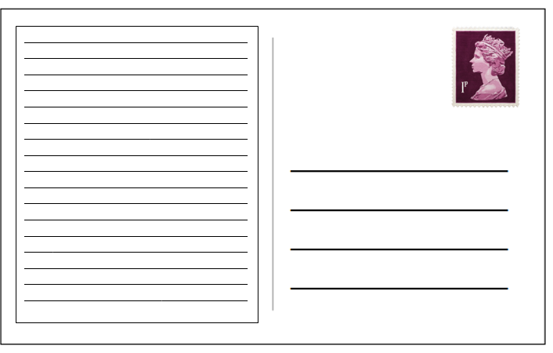

THE PRESENT PERFECT TENCE

A-Complete the sentences using the past participle of the verbs in brackets.

1. The train has ___________. We can go out now. (stop)
2. She isn’t ready. She hasn’t __________ her cases yet. (pack)
3. She has ___________ some photos. (take)
4. Sally hasn’t ___________ yet. Where can she be? (arrive)
5. I’ve never ____________ to your mother. (speak)
6. I haven’t ____________ which shoes to buy yet. (decide)
7. My father has ___________ to Rome. (drive)

B-Choose the correct verb from the box and complete the sentences using the present perfect form.

1. Tom _________________ the rubbish.
2. Claire ________________ all the questions.
3. I ___________________ ten kilometres.
4. They ________________ their car keys.
5. John ________________ a new jacket.
6. Diana ________________ her arm.
7. Bill and Tim _________________ the kitchen.
8. The train __________________ the station.
9. Karen _____________________ her violin practice.

answer break buy clean empty leave lose finish walk

C-Complete the sentences. Use the present perfect – positive or negative.

My mum isn’t at home now. She ___________ (go) to the supermarket.

So far this month I ______________ (see) three films.

I’m hungry. I _____________ (have) my lunch yet.

I _________________ (see) Helen yet today. Is she at school?

Our football team ________________ (win) all its matches so far this year.

I don’t know your boy-friend. I ____________ (meet) him yet.

D-Complete what Susan says. Use the PPT and ***for*** or ***since***.

a) I’m from France, but I live in London now.

I ____________ (live) here _________1992.

b) I’m a journalist. I work for a sports magazine in London. I ___________(work) there _________ two years.

c) I’m married. My husband’s name is Jonathan.

We _____________(be) married _________1993.

d) Jonathan works in a bank.

He ___________(work) there _________ three years.

e) We have a flat in south London.

We ________ (have) the flat ________ last May.

**NOTA: Entregue el taller cuando llegue a clases y prepárese para el EXAMEN sobre el trabajo. El trabajo vale un 40% y el examen un 60%.**



Put the words in the right order.

a) I/homework/yet/finished/ haven’t/my

______________________________

b) I/homework/my/done/have/already

______________________________

c) I/homework/my/finished/have/just

______________________________

d) He/home/gone/has/already

______________________________

e) Mark/come back/France/just/has/from

______________________________

f) They/bought/new/a/just/have/house

______________________________

g) We/had/lunch/haven’t/yet

______________________________

h) The train/the station/already/left/has

______________________________

i) left/the train/yet/has/?

______________________________