**English area improvement plan**

Teacher: **Luz MEry Mena Mena**

**Grade:** 10th

**Term**: FIRST

**Purpose**

To identify areas of improvement in English language skills and create a strategic plan to enhance proficiency in reading, writing, listening, and speaking. It aims to set goals, outline strategies, allocate resources, and track progress towards improving English language abilities.

To strengthen communication skills

**TOPIC**: Applications (apps)

**What is an app?**

An application (app), also known as software or program, is a set of instructions or code that performs specific tasks or functions on a computer or mobile device.

Look up another meaning of:

1. What is an app?
2. Make a list of different categories of apps
3. What are the most popular apps in the world? Functions of each of them
4. Benefits and potential drawbacks of using apps.
5. What factors should you consider when choosing an application?

Watch the following video: [Guess the Logo Quiz Apps Edition](https://youtu.be/i9nzBgR-Sl8?feature=shared)

**1. Taking into account the above explanation and video about apps, answer the following questions:**

1. What is your favorite mobile app, and why?

2. How often do you use apps on your mobile device?

3. What types of apps do you use the most (e.g., social media, productivity, gaming)?

4. Can you name six educational apps that you find helpful for studying?

5. How do you think mobile apps have changed the way we communicate?

6. What are the main reasons you use apps?

7. Are there any specific features or improvements you would like to see in apps?

8. Have you ever used any meditation or mindfulness apps? If so, how did they benefit you?

9. What are some gaming apps that you enjoy playing, and do you think they have any educational value?

10. What are some language translation apps that you find useful for communicating in different languages?

11. What are some popular music streaming apps that you use to discover and listen to music?

12. What are some positive and negative aspects of using an app?

13. Do you prefer free apps with ads or paid apps without ads, and why?

14. How many apps do you have installed on your device?

15. How apps have influenced various aspects of our lives?

**2.Read the description below and answer the questions**

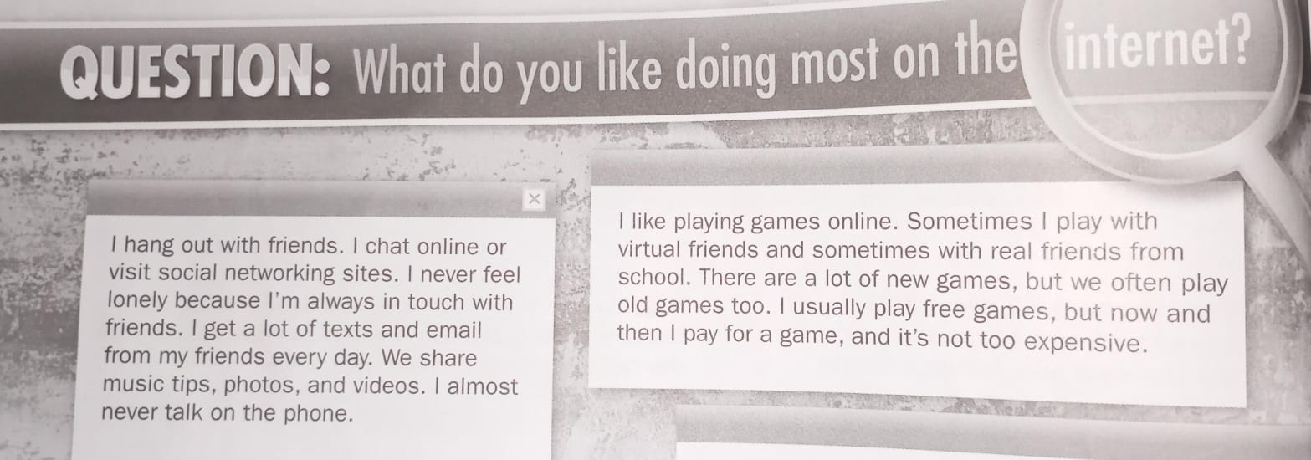

|  |  |  |
| --- | --- | --- |
| I love shopping online. Sometimes I buy clothes or CDs. I can get the latest things online, and it's fast to get them too. I don't mind waiting for the clothes to arrive, and the price is usually cheaper. I go to the mall from time to time - but usually only to window shop. | I like playing games online. Sometimes I play with virtual friends and sometimes with real friends from school. There are a lot of new games, but we often play old games too. I usually play free games, but now and then I pay for a game, and it's not too expensive. | I love shopping online. Sometimes I buy clothes or CDs. I can get the latest things online, and it's fast to get them too. I don't mind waiting for the clothes to arrive, and the price is usually cheaper. I go to the mall from time to time - but usually only to window shop. |

**1. What does the person usually do when they go to the mall?**

a) Buy a lot of items

b) Window shop without buying anything

c) Try on clothes without buying anything

**2. What does the person like about shopping online?**

a) The ability to try on clothes before buying them

b) The speed of getting the latest items

c) The social aspect of going to a physical store

**3. What does the person like about shopping online?**

a) The ability to try on clothes before buying them

b) The speed of getting the latest items

c) The social aspect of going to a physical store

**4. Who does the person play games with?**

a) Only virtual friends

b) Only real friends from school

c) Both virtual friends and real friends from school

**5. What types of games do they usually play?**

a) Only new games

b) Only old games

c) Both new and old games

**6. How often does the person pay for a game?**

a) Never, they only play free games

b) Occasionally, but it's very expensive

c) Now and then, but it's not too expensive

**7. How does the person feel about their social connections?**

a) They often feel lonely despite being in touch with friends

b) They never feel lonely because they're always in touch with friends

c) They sometimes feel lonely, regardless of being in touch with friends

**8. What type of communication do they receive from friends daily?**

a) Letters and postcards

b) Texts and emails

c) Phone calls and video chats

**9. How does the person primarily stay in touch with friends?**

a) Hanging out in person

b) Chatting online or visiting social networking sites

c) Talking on the phone

**10. How often does the person talk on the phone?**

a) Almost never

b) Occasionally, but not frequently

c) Frequently

Rearrange the words to make sentences

**ORAL PRESENTATION**

**3.Again, watch the video about the applications and select an app and make a PPT and oral presentation about this. The items to consider are the following:**

**Title**

**Introduction (Here is the explanation of the app)**

**Features**

**Positive aspects**

**Negative aspects**

**Benefits**

**Conclusion**