|  |  |  |
| --- | --- | --- |
|  | **MUNICIPIO DE MEDELLÍN** | Descripción: Resultado de imagen para participacion |
| **SECRETARÍA DE EDUCACIÓN MUNICIPAL** |
| **I.E. RODRIGO CORREA PALACIO**  Aprobada por Resolución 16218 de noviembre 27 de 2002  **DANE 105001006483 - NIT 811031045-6** |

**PLAN DE APOYO ACADEMICO DEL PRIMER PERIODO 2022**

**LENGUA CASTELLANA 3°**

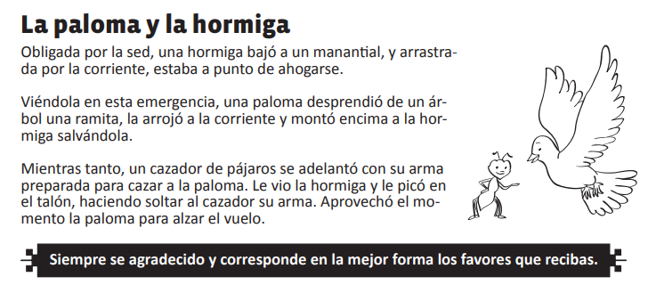

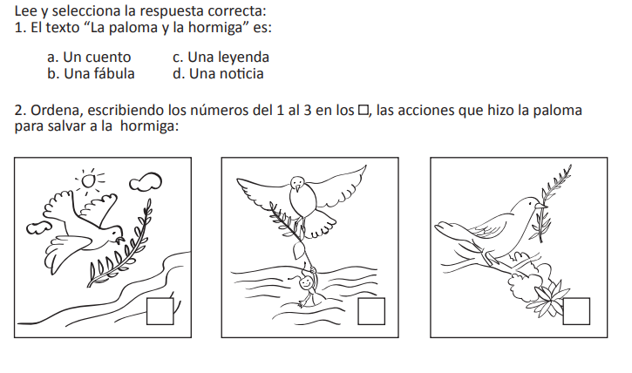

3. ¿Cómo salvó la hormiga a la paloma?

_____________________________________________________________________________________________________________________________________________________________________________________________________________________________________________________________________________________________________________________________________ _

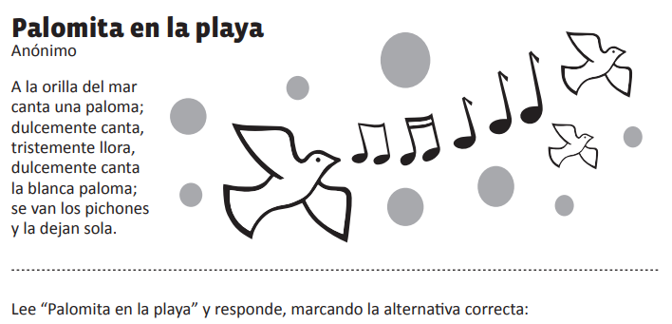

**4. 5.**

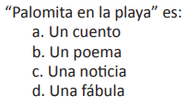 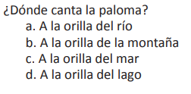

**6. ¿Por qué crees que llora la paloma?**

________________________________________________________________________________________________________________________________________________________________________________________________________________________________________________________________________________________________________

**7. Escribe el nombre de 7 animales que puedes encontrar en una granja.**

**1._______________________**

**2._______________________**

**3._______________________**

**4._______________________**

**5. _______________________**

**6._______________________**

**7._______________________**

**8. Escribe el plural para cada palabra.**

Ängel _____________________________ Mico _____________________________

Barro______________________________ Mesa _____________________________

Computador ________________________ Cuaderno __________________________

Tetero ____________________________ Cola _______________________________

Libros _____________________________ Carpintero _________________________

Plato ______________________________ Serpiente __________________________

Galleta ____________________________ Madera ____________________________

Cepillo ____________________________ Gancho ____________________________

**9. Escribe, según corresponda el singular o el plural de las palabras.**

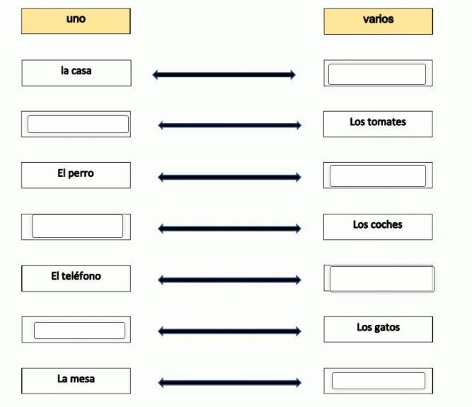

**10. Lee los siguientes sustantivos y clasifícalos en las categorías correspondientes**

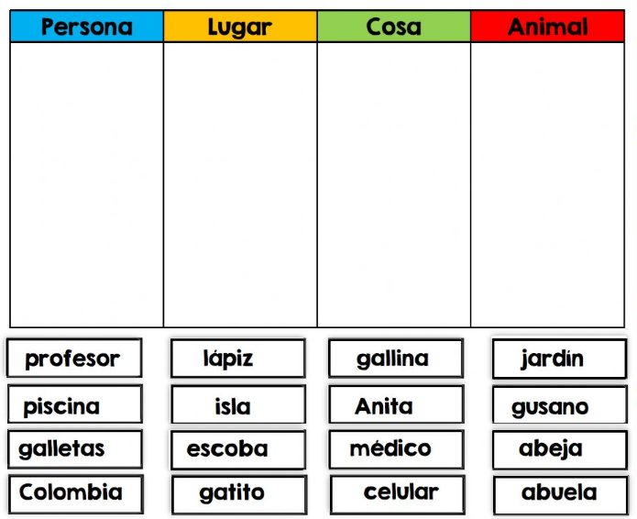

**11. Escribe dentro de cada frasco 8 ejemplos de sustantivos propios y 8 de sustantivos comunes.**

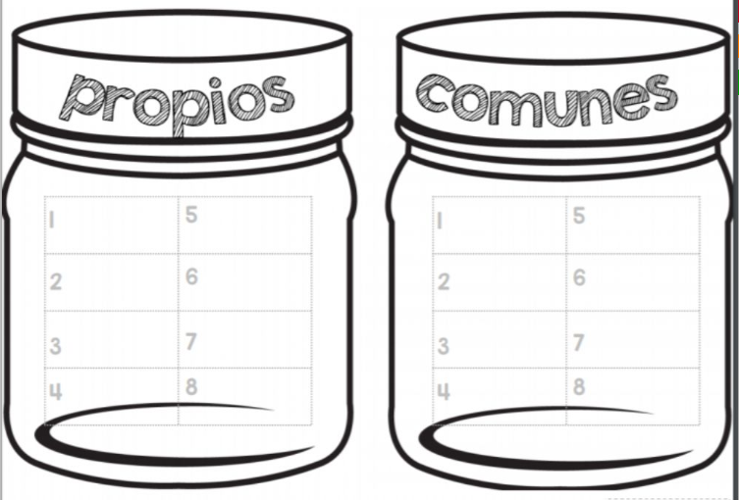

**12. Escribe un cuento y subraya con rojo 10 de los verbos que utilices.**

__________________________________

______________________________________________________________________________________________________________________________________________________________________________________________________________________________________________________________________________________________________________________________________________________________________________________________________________________________________________________________________________________________________________________________________________________________________________________________________________________________________________________________________________________________________________________________________________________________________________________________________________________________________________________________________________________________________________________________________________________________________________________________________________________________________________________________________________________________________________________________________________________________________________________________________________________________________________________________________________________________________________________________________________________________________________________________________________________________________________________________________________________________________________________________________________________________________________________________________________________________________________________________________________________________________________________________________________________________________