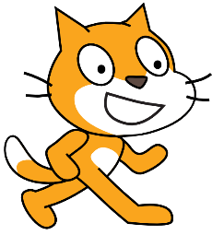Scratch Project Intermediate Level Design

I.E. COLEGIO LOYOLA PARA LA CIENCIA Y LA INNOVACIÓN
TECNOLOGÍA, INFORMÁTICA Y EMPRENDIMIENTO
GRADO OCTAVO 2019

Authors
Name | Rol | Grade

Project Name

Project Description

Design Elements

Sprites

Name and description | Main Pic | Customes | background to which it belongs | Behavior (conditions)
If you need more space, use an additional sheet. If in doubt, ask teacher Juan Pablo about the proper distribution of your sprites inside the sheet.

Backgrounds

Background name | Pic | Description
If you need more space, use an additional sheet. If in doubt, ask teacher Juan Pablo about the proper distribution of your backgrounds inside the sheet.

Sounds

Name | Sprite or background to which it belongs | Situations or conditions under which it will sound

Sensors

Sensor Name | Sprite or background to which it controls | Situations or conditions under which it will control the sprite or the background

Process Rules
No. | Section | Behavior | Sprite involved | How the behavior is controled? | Description
1.

2.

3.

4.

5.

6.

7.

8.

9.

10.

11.

12.

List of Variables

Variable Name | Description

