**TALLER DE INGLES**

**4TO. GRADO**

1. **COMPLETE THE SENTENCES ABOUT SPORTS**

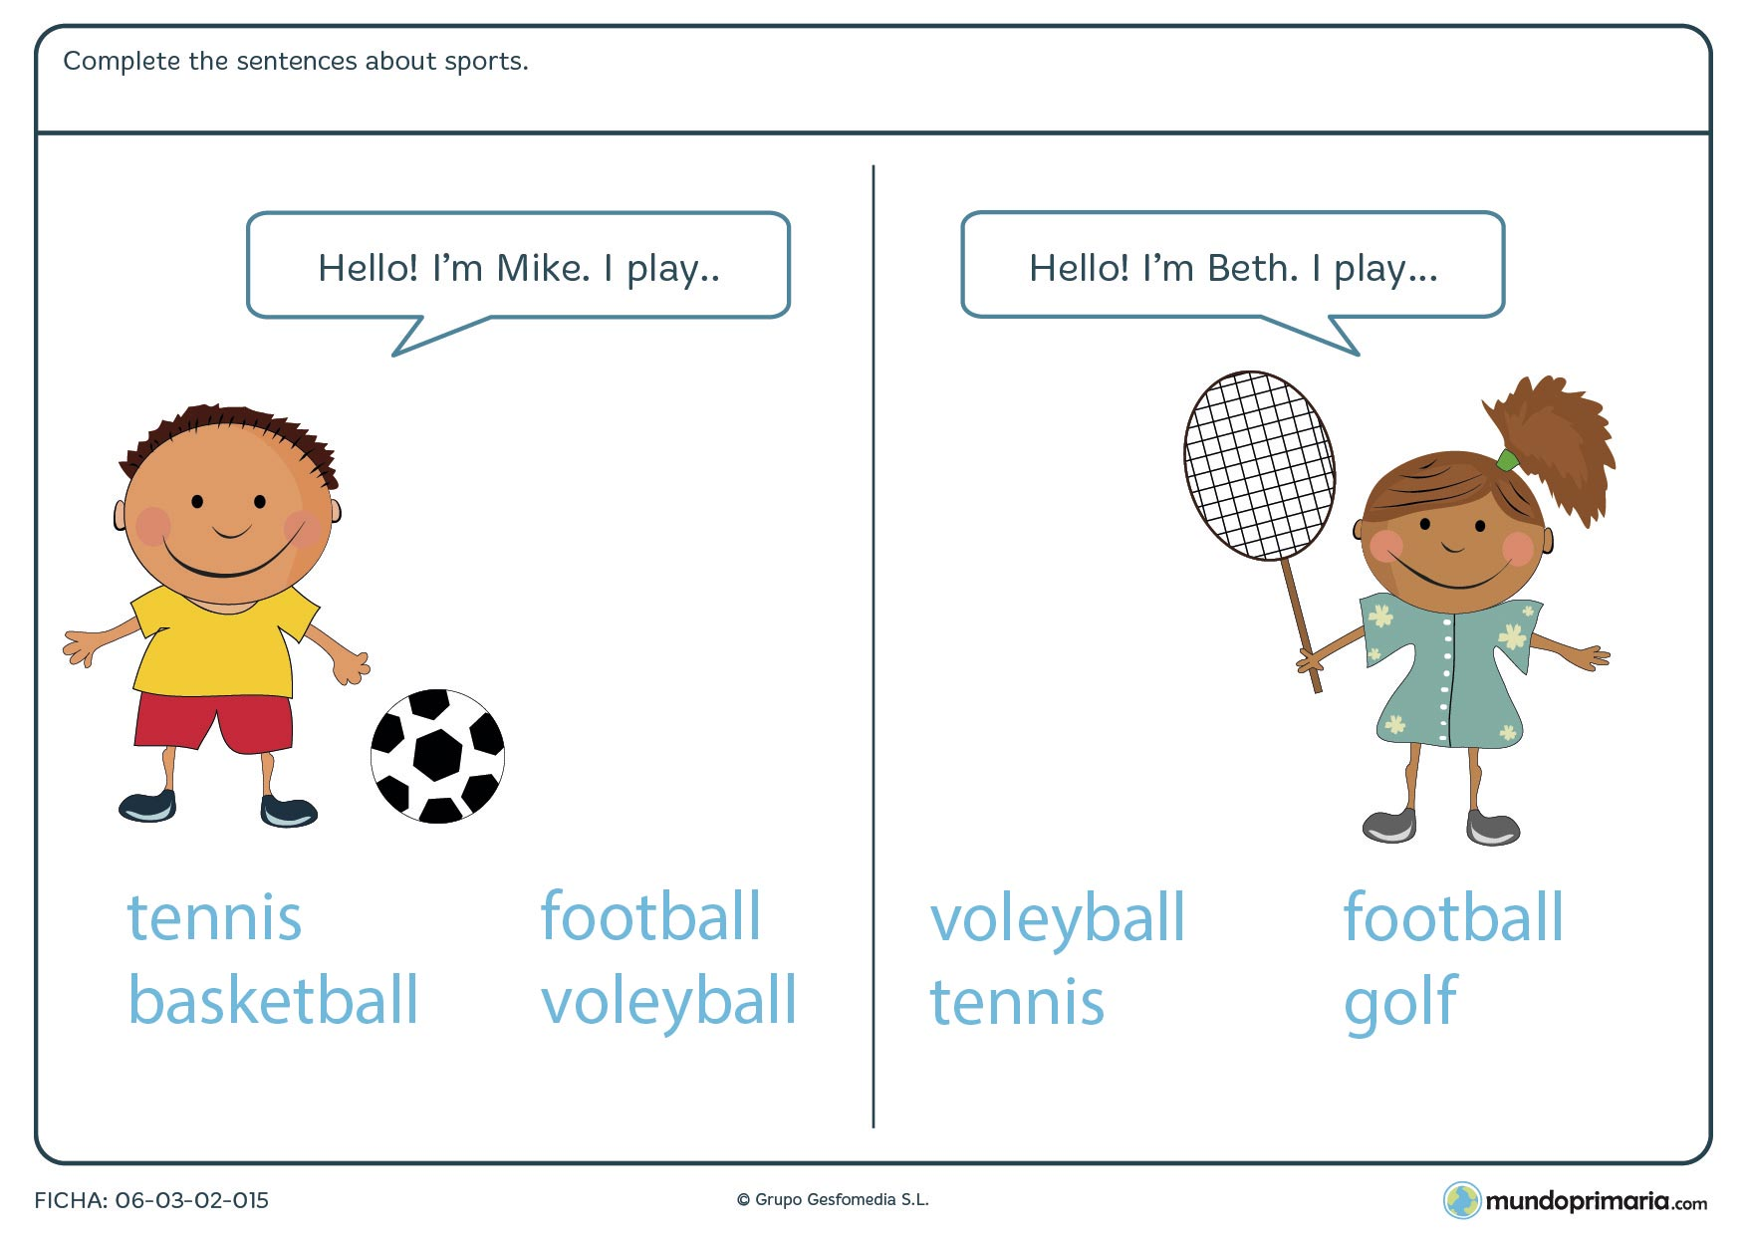

1. **DRAW A PICTURE WHIT THE SPORS LISTED BELOW**

* **TENNIS**
* **BASKETBALL**
* **FOOTBALL**
* **VOLEYBALL**
* **GOLF**

1. **WATCH THE VIDEO BELOW AND PRACTICE THE RIGHT WAY TO SAY HELLO (Observa el siguiente video y práctica la forma correcta de saludar)**

**Video: “no digas “hello”/ como decir “hola” en ingles”**

<https://www.youtube.com/watch?v=C7UOm1wV4mI>

1. **READ THE SHORT PASAGE AND ANSWER THE QUESTIONS**

**Lily has three roses. Her dad gave them to her for Valentine’s day. The roses are pink. Lily loves her roses!**

|  |  |
| --- | --- |
| * **What does Lily have?** | * A bow * Roses * A dog |
| * **Who gave them to her?** | * Her mom * Her dad * Her friend |
| * **What color are they?** | * Pink * White * red |

1. **THE COLORS. Color the instruction words**

